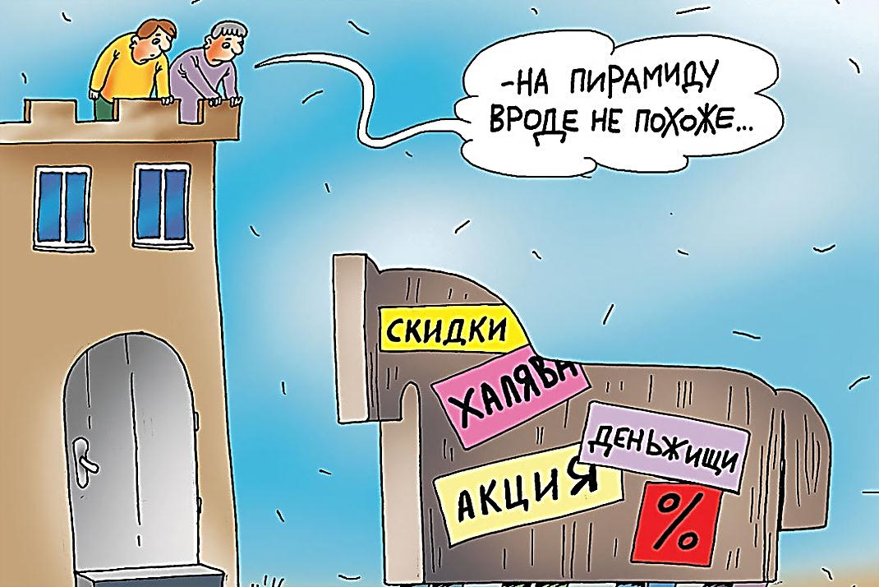
1

Проблема:
_______________________________________________________________________________________________________________________________________________________________________
Памятка «___________________________________________________________________________________»
_______________________________________________________________________________________________________________________________________________________________________________________________________________________________________________________________________________________________________________________________________________________________________________________________________________________________________________________________________________________________________________________________________________________________________________________________________________________________________________________________________________________________________________________________________________________________________________________________________________________________________________________________________________________________________________________________________________________________________________________________________________________________________________________________________________________________________________________________________________________________________________________________________________________________________________________________________________________________________________________________________________________________________________________________________________

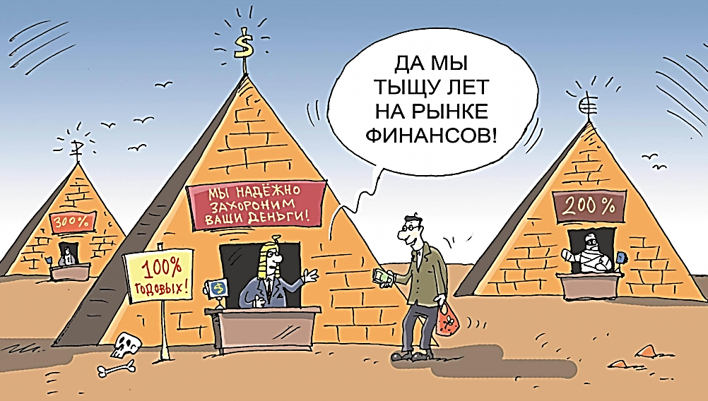
2

Проблема:
_______________________________________________________________________________________________________________________________________________________________________
Памятка «___________________________________________________________________________________»
_______________________________________________________________________________________________________________________________________________________________________________________________________________________________________________________________________________________________________________________________________________________________________________________________________________________________________________________________________________________________________________________________________________________________________________________________________________________________________________________________________________________________________________________________________________________________________________________________________________________________________________________________________________________________________________________________________________________________________________________________________________________________________________________________________________________________________________________________________________________________________________________________________________________________________________________________________________________________________________________________________________________________________________________________________________

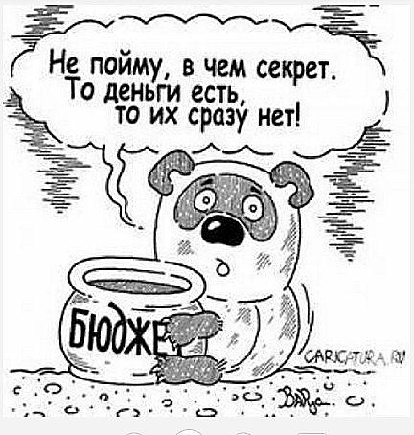
3

Проблема:
_______________________________________________________________________________________________________________________________________________________________________
Памятка «___________________________________________________________________________________»
_______________________________________________________________________________________________________________________________________________________________________________________________________________________________________________________________________________________________________________________________________________________________________________________________________________________________________________________________________________________________________________________________________________________________________________________________________________________________________________________________________________________________________________________________________________________________________________________________________________________________________________________________________________________________________________________________________________________________________________________________________________________________________________________________________________________________________________________________________________________________________________________________________________________________________________________________________________________________________________________________________________________________________________________________________________

4

Проблема:
_______________________________________________________________________________________________________________________________________________________________________
Памятка «___________________________________________________________________________________»
_______________________________________________________________________________________________________________________________________________________________________________________________________________________________________________________________________________________________________________________________________________________________________________________________________________________________________________________________________________________________________________________________________________________________________________________________________________________________________________________________________________________________________________________________________________________________________________________________________________________________________________________________________________________________________________________________________________________________________________________________________________________________________________________________________________________________________________________________________________________________________________________________________________________________________________________________________________________________________________________________________________________________________________________________________________
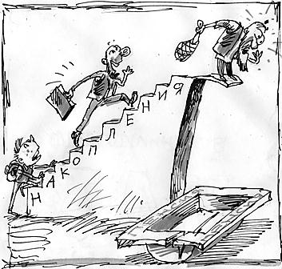
4

Проблема:
_______________________________________________________________________________________________________________________________________________________________________
Памятка «___________________________________________________________________________________»
_______________________________________________________________________________________________________________________________________________________________________________________________________________________________________________________________________________________________________________________________________________________________________________________________________________________________________________________________________________________________________________________________________________________________________________________________________________________________________________________________________________________________________________________________________________________________________________________________________________________________________________________________________________________________________________________________________________________________________________________________________________________________________________________________________________________________________________________________________________________________________________________________________________________________________________________________________________________________________________________________________________________________________________________________________________

