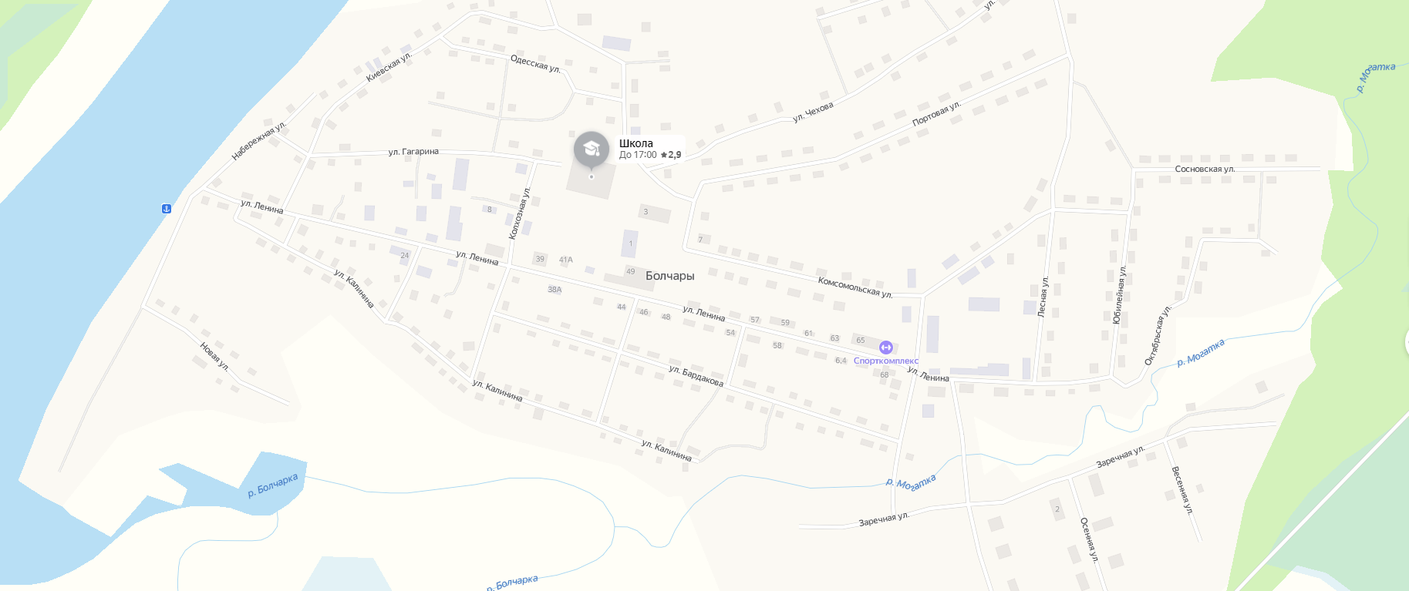

https://yandex.ru/maps/?from=api-maps&ll=68.817855%2C59.814070&mode=poi&origin=jsapi_2_1_79&poi%5Bpoint%5D=68.809190%2C59.815925&poi%5Buri%5D=ymapsbm1%3A%2F%2Forg%3Foid%3D175882546516&z=15.8

